Network Distributed Computing
Title: Assignment 2 - Testing template

Student Name:
David Thornton

Student Number:

B00152842

Overview

For each of the different URLs shown at the end of the assignment 2 brief, fill in this document to capture and discuss the results of each test. There are six URLs in total, and we will test each of them by sending varying amounts of traffic (virtual users) to each URL.

We are interested in documenting any issues and changes the server had while we were adding different amounts of virtual users (e.g., the stress) to the server.

We are also interested in finding out if there is a limit to the number of virtual users we can send to the server before it crashes. Each URL for the website has different amounts of content on them which will also impact how long they take to load.

When loading Locust, we can change the number of virtual users we send to the URL. Start with a low number such as 10 and slowly move up, e.g., 20, 50, 100. etc. The number of users greatly impacts the results.
Document your findings with text and screenshots. The more detail, discussion and conclusions around the results you have, the better your overall grade will be.

Create one test log for each URL. For each URL, test different amounts of virtual users.

Test 1

URL of page tested
/

The number of virtual users used
100

Ramp-up period
50s

Requests per second

600

Failures

0

Response Times - Get this from the statistics section of Locust. Discuss what do you see in these results.

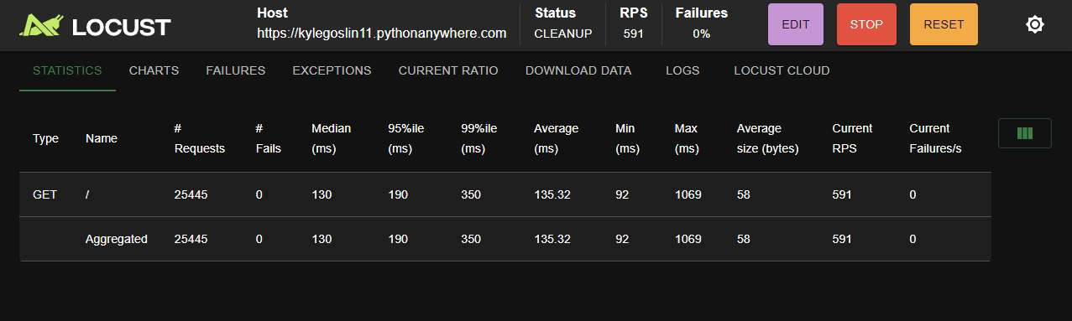

Response times were consistent throughout, always staying below or at 0.2 seconds.

For 10 users, the response time is ~0.12 seconds

It stays at this until 60 users, where it begins to increase again

Eventually levelling again once all 100 users joined at ~0.2 seconds

Graph output - Show a graph that you think had interesting results and discuss what you see. Are there any interesting results?

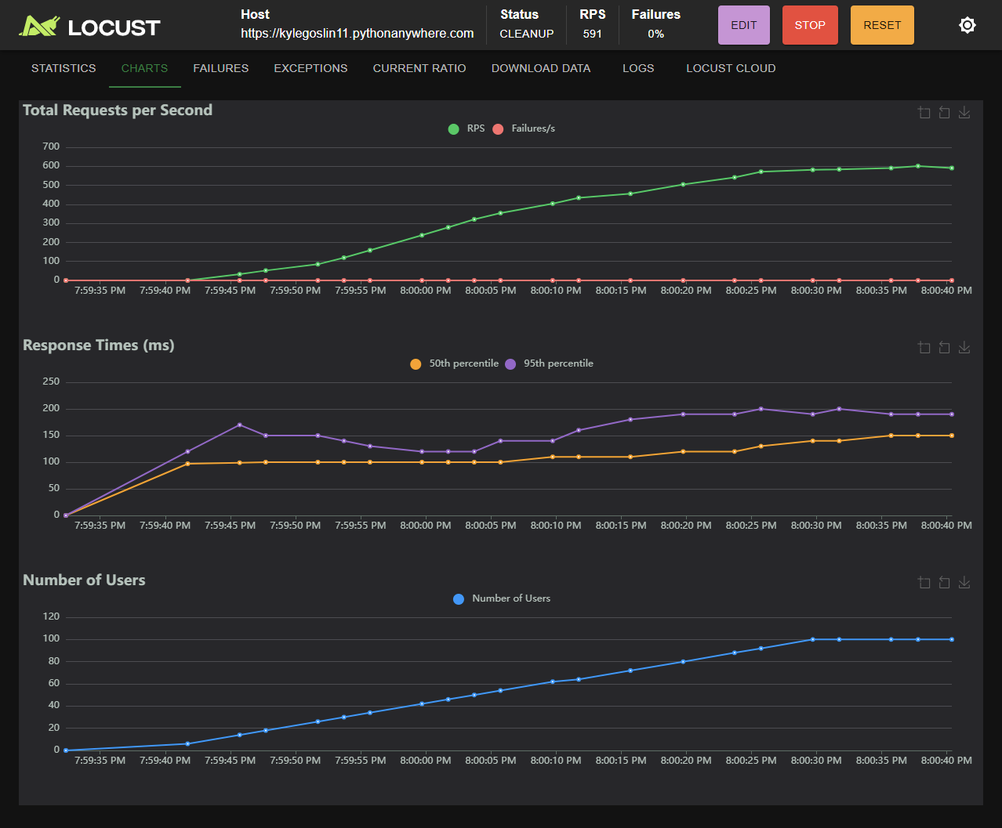

The requests per second stayed consistent relative to the number of users throughout, showing that the number of users didn’t affect the return rate for the page to significantly.

The page maintained 0 failures throughout testing

Local machine CPU / RAM Load - What impact did this have on your machine?

Throughout all tests, CPU and RAM load remained low

What did the test results show you overall?

This page is consistent in its low response times and has a very high success rate

Could the server handle the traffic in your opinion? Why or why not? What evidence backs up your claim? What was the maximum amount of traffic the server could take?

This server handled the traffic very well. With no failures and very low response times, this server could handle far more requests to this page then tested.

Test 2

URL of page tested
/page1

The number of virtual users used
100

Ramp-up period
50s

Requests per second

520

Failures

0

Response Times - Get this from the statistics section of Locust. Discuss what do you see in these results.

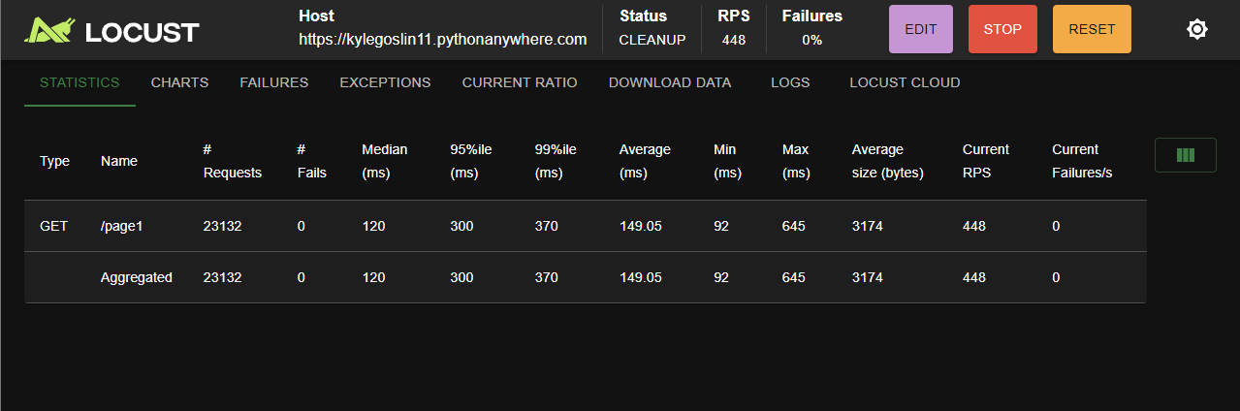

This page had very good response times, averaging ~ 0.15 seconds throughout.

Aside from an initial spike at the start of testing, from 0 to 80 users, response times remained under 0.2 seconds

From 80+ users, response times began to increase to 0.4 seconds and levelled off at ~0.35 seconds, not as good but still barely noticeable

Graph output - Show a graph that you think had interesting results and discuss what you see. Are there any interesting results?

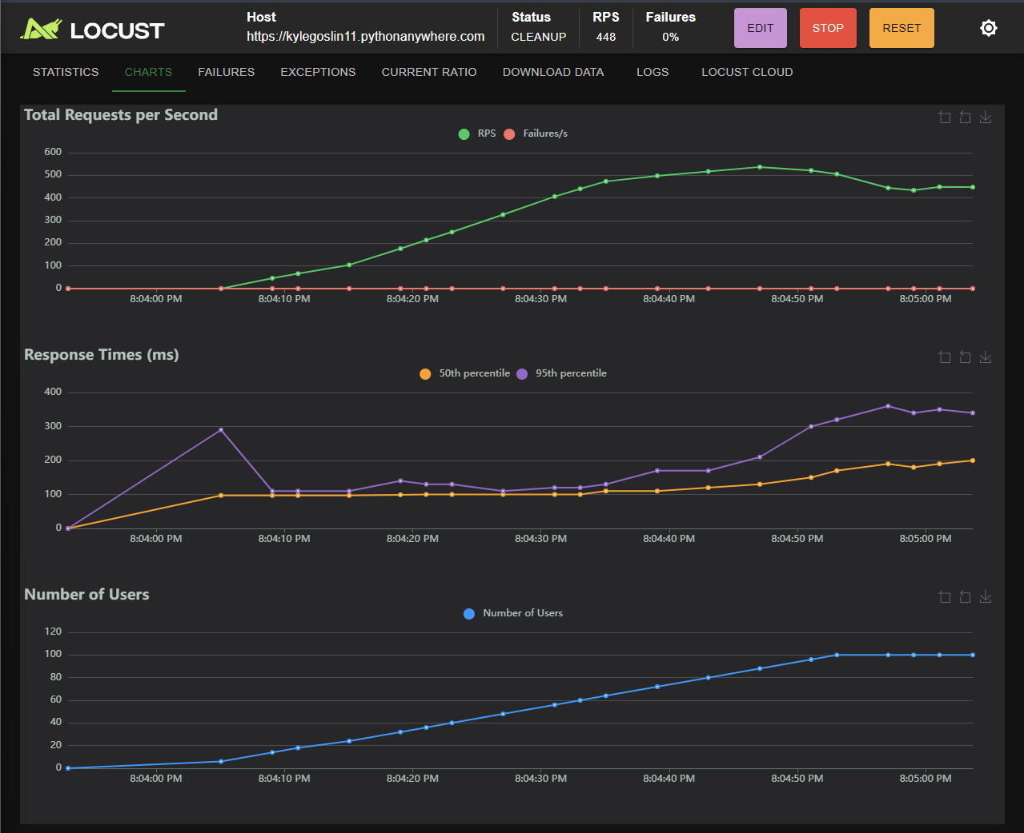

Total requests per second stayed mostly consistent with the number of users

However, as the number of users began to reach 60+ requests began to taper off, seeming to cap at ~ 550 per second

Local machine CPU / RAM Load - What impact did this have on your machine?

Throughout all tests, CPU and RAM usage stayed low

What did the test results show you overall?

The server remains consistent in its response times throughout the tests

Could the server handle the traffic in your opinion? Why or why not? What evidence backs up your claim? What was the maximum amount of traffic the server could take?

The server handled the traffic to this page well, maintaining a response time below 0.4 seconds even at its worst point. It seemed to cap off at around 500 requests per second, but this was still more then enough for the number of users in this test

Test 3

URL of page tested
/page2

The number of virtual users used
100

Ramp-up period
50s

Requests per second

480

Failures

0

Response Times - Get this from the statistics section of Locust. Discuss what do you see in these results.

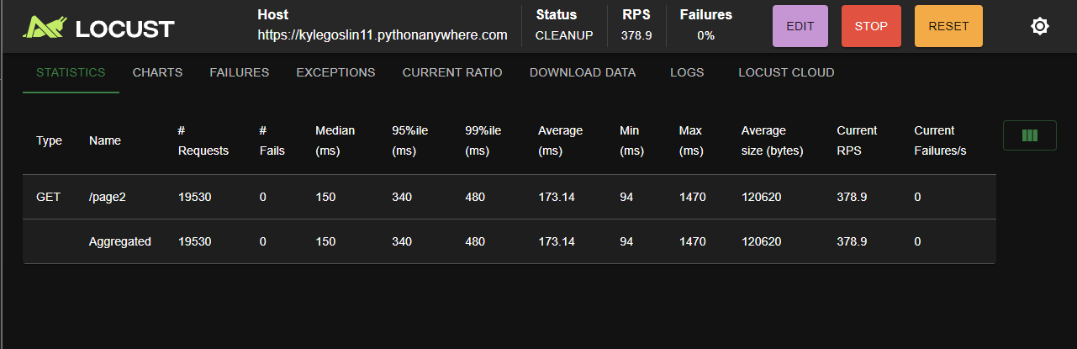

The server maintained consistently good response times throughout tests.

After an initial spike from 0 to 15 users, response times stayed consistently under 0.25 seconds for most of the tests, performing well below the expected.

At around 80 users this increased to ~ 0.5 seconds at the end of testing, were it was still increasing.

Graph output - Show a graph that you think had interesting results and discuss what you see. Are there any interesting results?

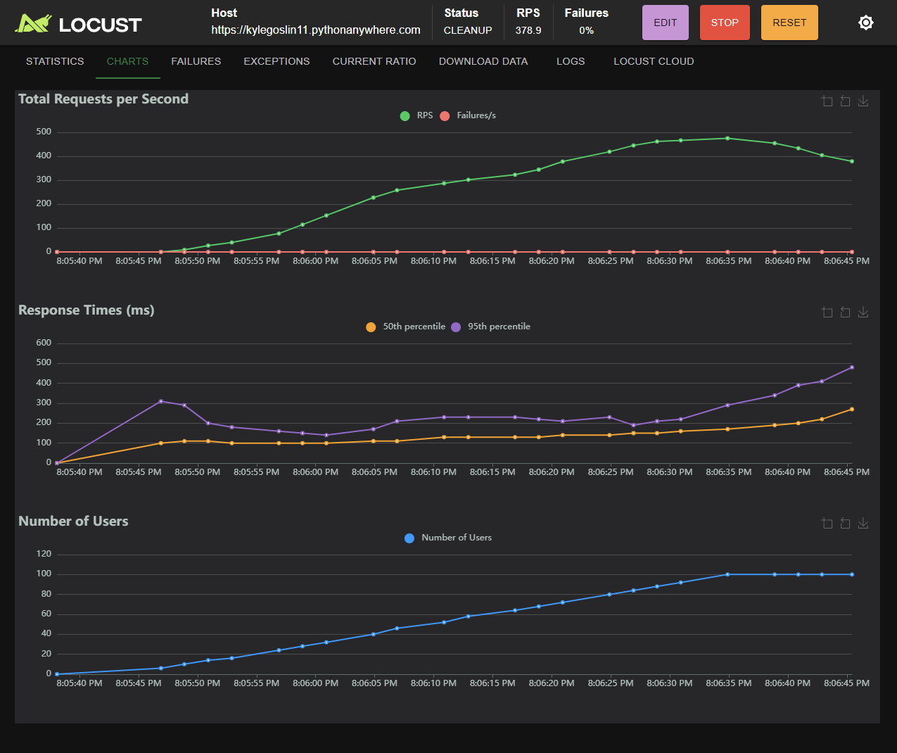

Requests per second remained consistent throughout testing relative to the number of users at ~ 5 requests per second per users per second, reducing slightly at the end of the testing period to ~ 4 requests per user per second, still sufficient.

Local machine CPU / RAM Load - What impact did this have on your machine?

CPU usage approached 90 percent at around 80 users but then reduced again before the end of the test, possibly a fluke

What did the test results show you overall?

The results of this test showed that the page was consistent overall, and likely could have supported more users if required

Could the server handle the traffic in your opinion? Why or why not? What evidence backs up your claim? What was the maximum amount of traffic the server could take?

The server handled the traffic sent to it well, with response times staying reasonably below 0.5 seconds throughout even at a high number of requests per second. Although spikes at the end of the test period could suggest that the performance of the site could struggle with a substantial increase in users

Test 4

URL of page tested
/page3

The number of virtual users used
100

Ramp-up period
50s

Requests per second

570

Failures

0

Response Times - Get this from the statistics section of Locust. Discuss what do you see in these results.

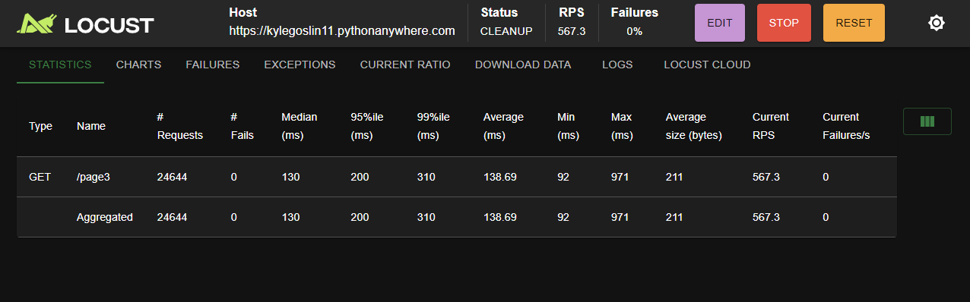

Response times for this page were great overall, maxing out at ~ 0.25 seconds, well below what would be expected

The initial spike in this test took longer to go back to normal then in others, staying at around 0.2 seconds, not reducing fully until 40 users, where it drops to ~ 0.12 seconds for a short period before gradually increasing to 0.25 seconds at the end of testing, staying level at this time

Graph output - Show a graph that you think had interesting results and discuss what you see. Are there any interesting results?

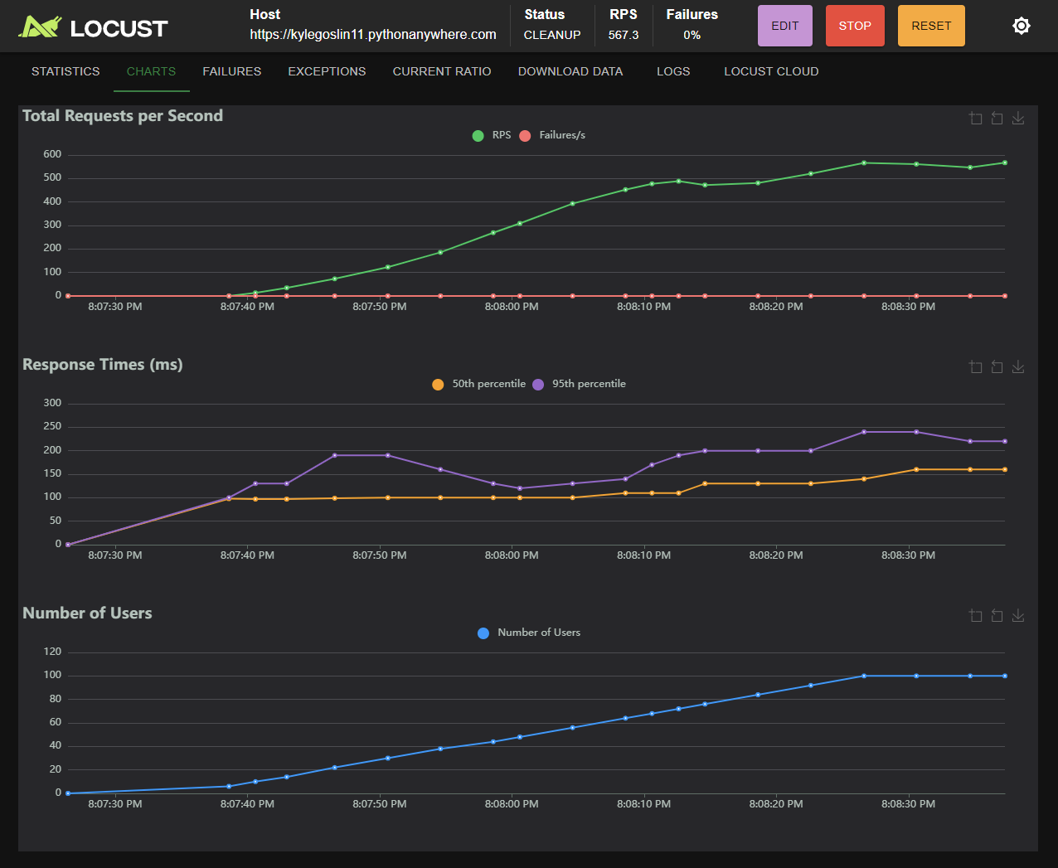

Request per second in this tests stayed relatively consistent with the number of users, showing a very strong correlation to the response times throughout the later portion of the test.

Response times increase with the number of users until 75 users, when rise and fall between 500 and per second until the end of the test

Local machine CPU / RAM Load - What impact did this have on your machine?

No noteworthy effect on CPU or RAM throughout tests

What did the test results show you overall?

Overall the tests showed great response times and no failures throughout, with relatively consistent response times and requests per second

Could the server handle the traffic in your opinion? Why or why not? What evidence backs up your claim? What was the maximum amount of traffic the server could take?

The server handled the traffic in this test excellently, never exceeding 0.25 second response times, being barely noticeable

Test 5

URL of page tested
/page4

The number of virtual users used
100

Ramp-up period
50s

Requests per second

60

Failures

785 (99%)

Response Times - Get this from the statistics section of Locust. Discuss what do you see in these results.

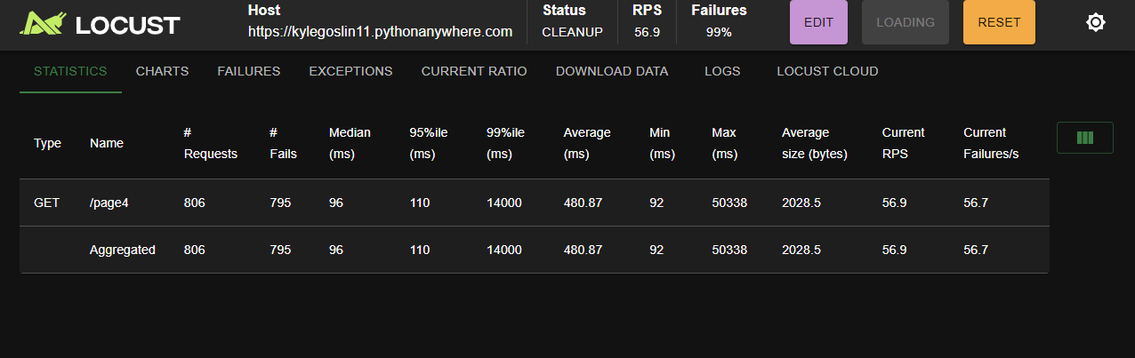

Response times were extremely pore in this test, reaching 50 seconds at its worst point before ending

Response times increased as the time the test ran for did

Graph output - Show a graph that you think had interesting results and discuss what you see. Are there any interesting results?

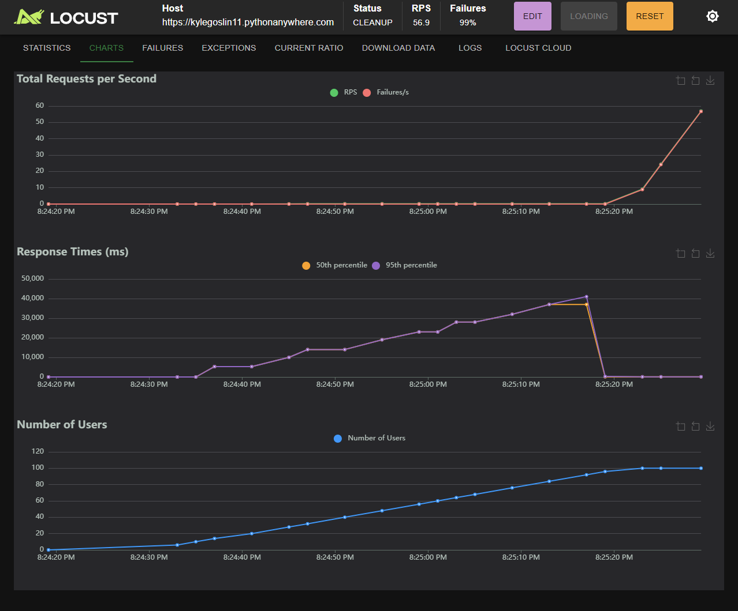

With 99% failures, most requests didn’t get a response before the end of the test, with only 11 of 806 requests being successful

Local machine CPU / RAM Load - What impact did this have on your machine?

No notable CPU or RAM constraints throughout this test

Testing done on the local machine, done due to irregular results, hasn’t shown any irregularities

What did the test results show you overall?

Considering the number of failed requests, even at low user numbers, the server was likely either experiencing some kind of external demand, the there is an issue with the testing software or the page being tested is likely unusable, too big to be realistically used

NOTE:
Later tests have showed that this particular page could not handle the number of users sent to it, causing the server to shut down.

Could the server handle the traffic in your opinion? Why or why not? What evidence backs up your claim? What was the maximum amount of traffic the server could take?

Further testing of the server and this page is needed to clarify

Further tests have shown that this page is massively underperforming compared to others, more details in later tests

Test 6

URL of page tested
/page4

The number of virtual users used
10

Ramp-up period
10s

Requests per second

1.2

Failures

0

Response Times - Get this from the statistics section of Locust. Discuss what do you see in these results.

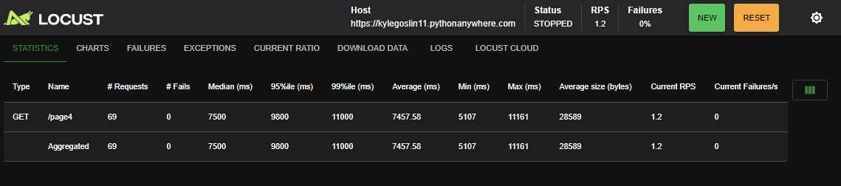

Even for only 10 user, this page have very long response times for tests overall

For 10 users, this page had between 10 and 12 second response times, not realistically viable for a commercial website

Graph output - Show a graph that you think had interesting results and discuss what you see. Are there any interesting results?

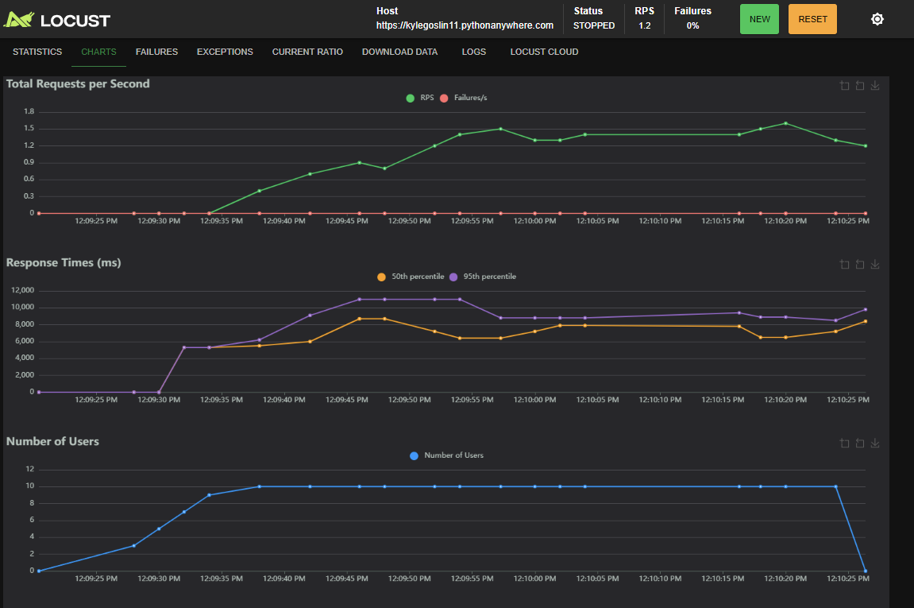

This page had between 1 and 1.5 requests per second on average, earlier testing would suggest that any more than 10 users would have resulted in massive failure rates throughout

Local machine CPU / RAM Load - What impact did this have on your machine?

No notable change in CPU or RAM usage for this page

What did the test results show you overall?

Overall, this page has very long response times and a very low response rate, although maintaining a 0 percent failure rate

Could the server handle the traffic in your opinion? Why or why not? What evidence backs up your claim? What was the maximum amount of traffic the server could take?

This server handled the traffic in this test very poorly, despite the small testing size. Most users would not except the 10 to 12 second response times the server produced for this page, and beyond 10 users the page would have likely failed.

Test 7

URL of page tested
/page5

The number of virtual users used
10

Ramp-up period
10s

Requests per second

~ 0.8

Failures

0

Response Times - Get this from the statistics section of Locust. Discuss what do you see in these results.

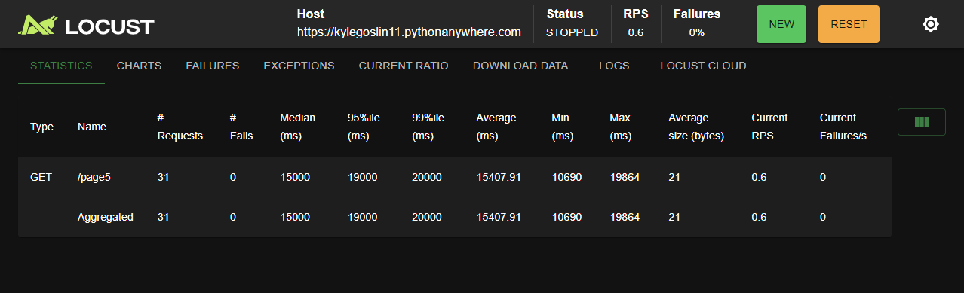

The response times for this page were poor overall

For 10 users the response times were between 15 and 20 seconds throughout testing

Graph output - Show a graph that you think had interesting results and discuss what you see. Are there any interesting results?

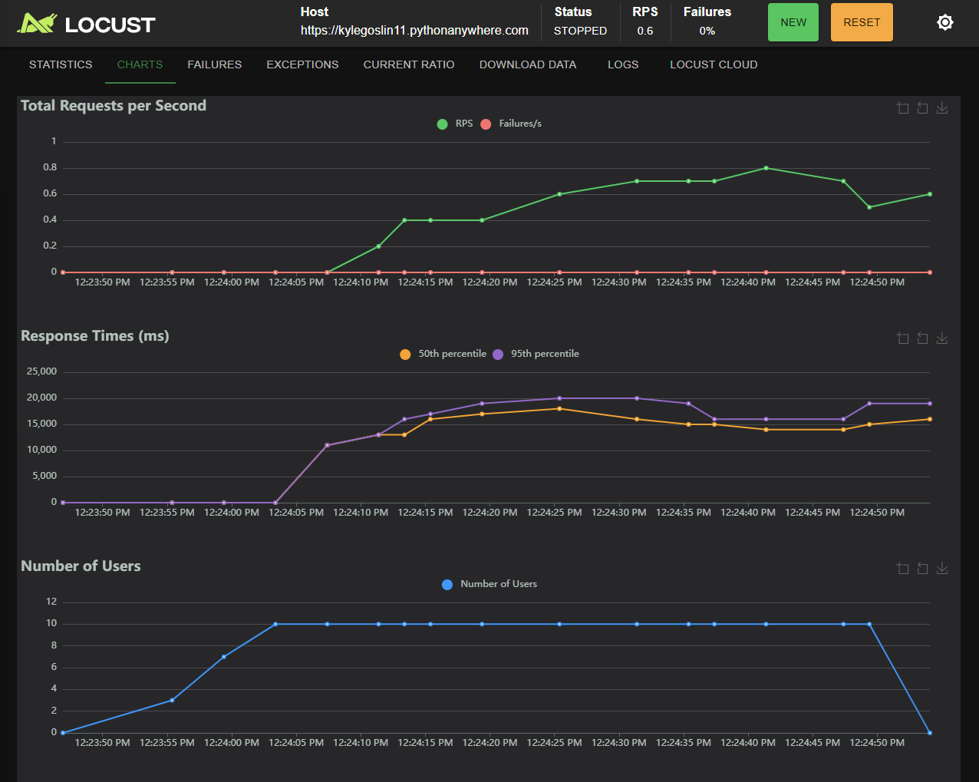

For 10 users, this page had around 0.6 requests per second in this test, likely due to poor response times

Local machine CPU / RAM Load - What impact did this have on your machine?

No notable affect to CPU or RAM usage

What did the test results show you overall?

Overall this page performed very poorly, with 20 second response times most users would find this page unusable

Could the server handle the traffic in your opinion? Why or why not? What evidence backs up your claim? What was the maximum amount of traffic the server could take?

The server did not handle the traffic well in this test. Despite the 0 percent fail rate, the poor response times and requests per second make this page relatively unusable, and the server likely would have crashed with any more traffic

Test 8

URL of page tested
/ , /page1 , /page2, /page3

The number of virtual users used
100

Ramp-up period
50

Requests per second

400

Failures

3 (>1%)

Response Times - Get this from the statistics section of Locust. Discuss what do you see in these results.

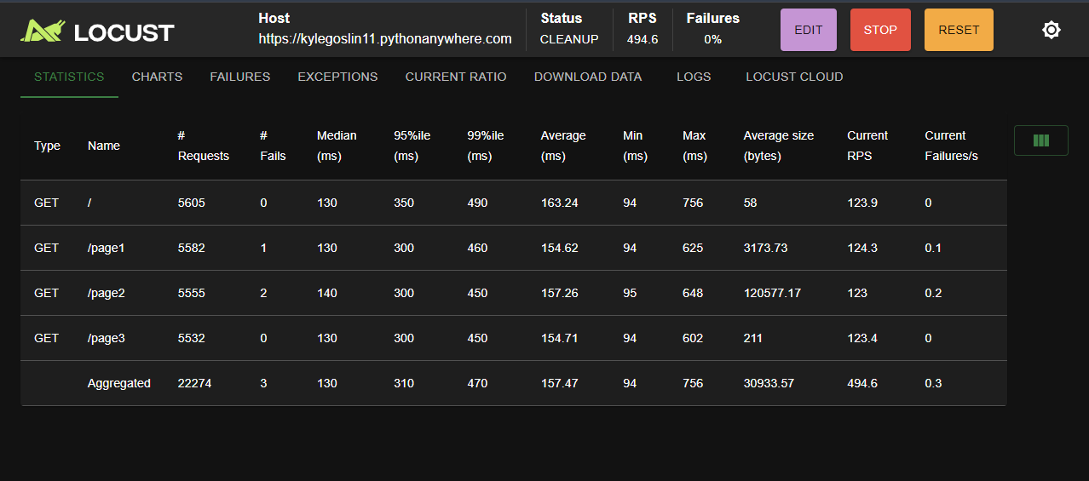

Response times for this test were very good overall, averaging ~ 0.25 seconds

There was an initial spike from 0 to 15 users, peaking at 0.3 seconds

I then stayed between 0.2 and 0.25 until 80 users, when response times began to increase, ending at round 0.48 seconds

All these are perfectly acceptable times

Graph output - Show a graph that you think had interesting results and discuss what you see. Are there any interesting results?

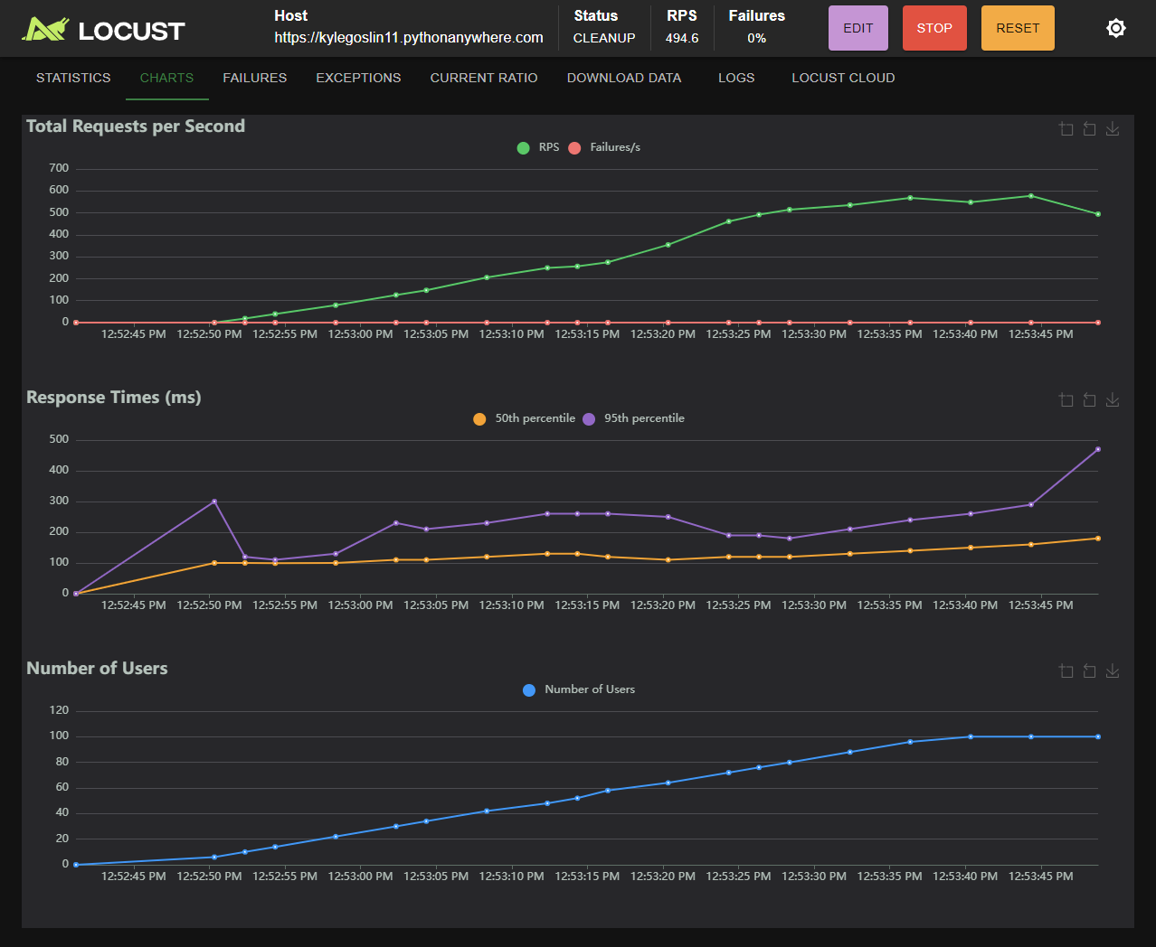

Requests per second stayed consistent throughout the majority of this test, dipping slightly towards the end of the test

The 0 percent fail rate for this test was actually slightly above 0, as we saw some failures beginning to occur towards the end of this test, showing the server was under some stress but no enough to suggest crashes with this number of users, but could be tested further.

Local machine CPU / RAM Load - What impact did this have on your machine?

No notable events in CPU or RAM usage

What did the test results show you overall?

Overall these pages functioned well above the standard for this test.

Could the server handle the traffic in your opinion? Why or why not? What evidence backs up your claim? What was the maximum amount of traffic the server could take?

The server handled the traffic in this test well, despite the few failures and increased response time towards the end of this test, the server maintained near 0 percent failures throughout and sub 0.5 second response times, being barely noticeable

Test 9

URL of page tested
/page3

The number of virtual users used
100

Ramp-up period
2s

Requests per second

~ 600

Failures

754 (2%)

Response Times - Get this from the statistics section of Locust. Discuss what do you see in these results.

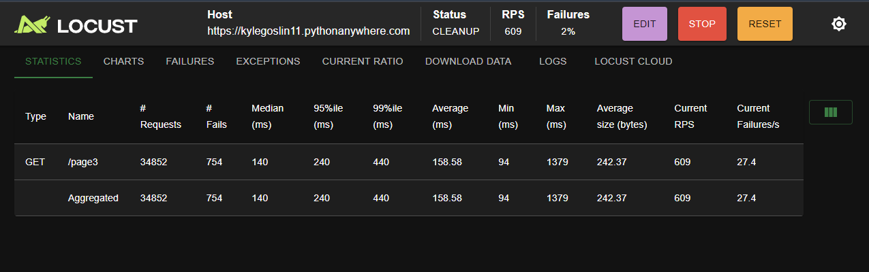

Response times remained low throughout this test

There was an significant initial spike to response times (expected) to about 0.5 seconds

It then reduced back down to ~ 0.25 seconds for the rest of this test

Graph output - Show a graph that you think had interesting results and discuss what you see. Are there any interesting results?

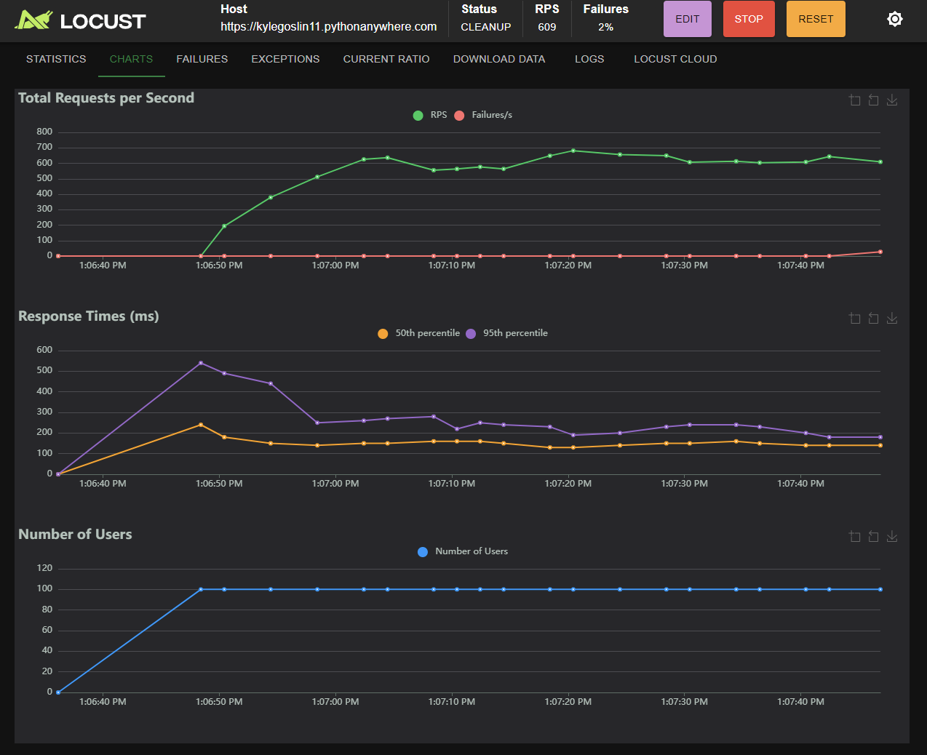

The main purpose of this test to was to see how the server handled a large initial spike in user numbers. Although this did result in initial response times being greater than typical for this page, it still remained low throughout testing

Oddly enough, none of the failed request of this test came from this initial ramp up in tests but rather from the end of this test run, suggesting that longer tests may be needed to discover additional issues

Local machine CPU / RAM Load - What impact did this have on your machine?

No notable change in CPU or RAM load

What did the test results show you overall?

Overall, this test showed that the server was able to comfortably handle a large spike in user numbers, even on this page3, the largest of the “useable” pages

However, it did indicate a need for longer test, considering all the failures of this test were at the end, when the server conditions should have continued to be stable, since no new users had been added for almost a minute

Could the server handle the traffic in your opinion? Why or why not? What evidence backs up your claim? What was the maximum amount of traffic the server could take?

The server handled the traffic from this test well. The server did initially have higher response times, but considering the nature of this test and the fact that its peak was at just over 0.5s per request, still perfectly usable and barely noticeable, I would say the server passed this test well

Test 10

URL of page tested
/page2

The number of virtual users used
150

Ramp-up period
75

Requests per second

Averaging 300

Failures

11594 (12%)

Response Times - Get this from the statistics section of Locust. Discuss what do you see in these results.

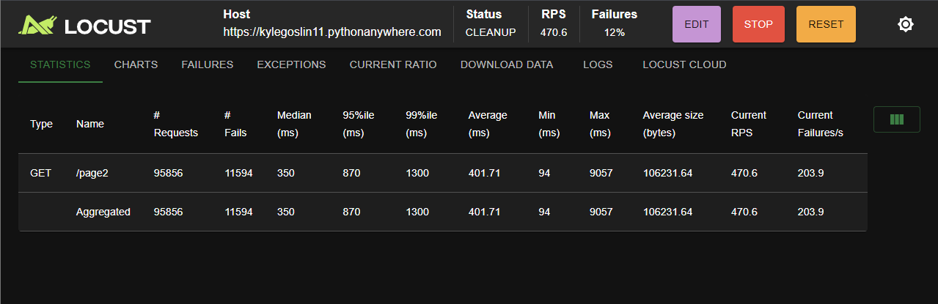

This page in this test had varying response times, due to the length of the test

Response times stayed relatively low while gaining users in this test rising and falling around 0.6 seconds.

As the test went on, response times fluctuated, reaching a maximum of 1.8 seconds, approaching the upper limits of what would be considered acceptable for users

Response times averaged around 1 second overall, which isn’t incredible but still an acceptable time

Graph output - Show a graph that you think had interesting results and discuss what you see. Are there any interesting results?

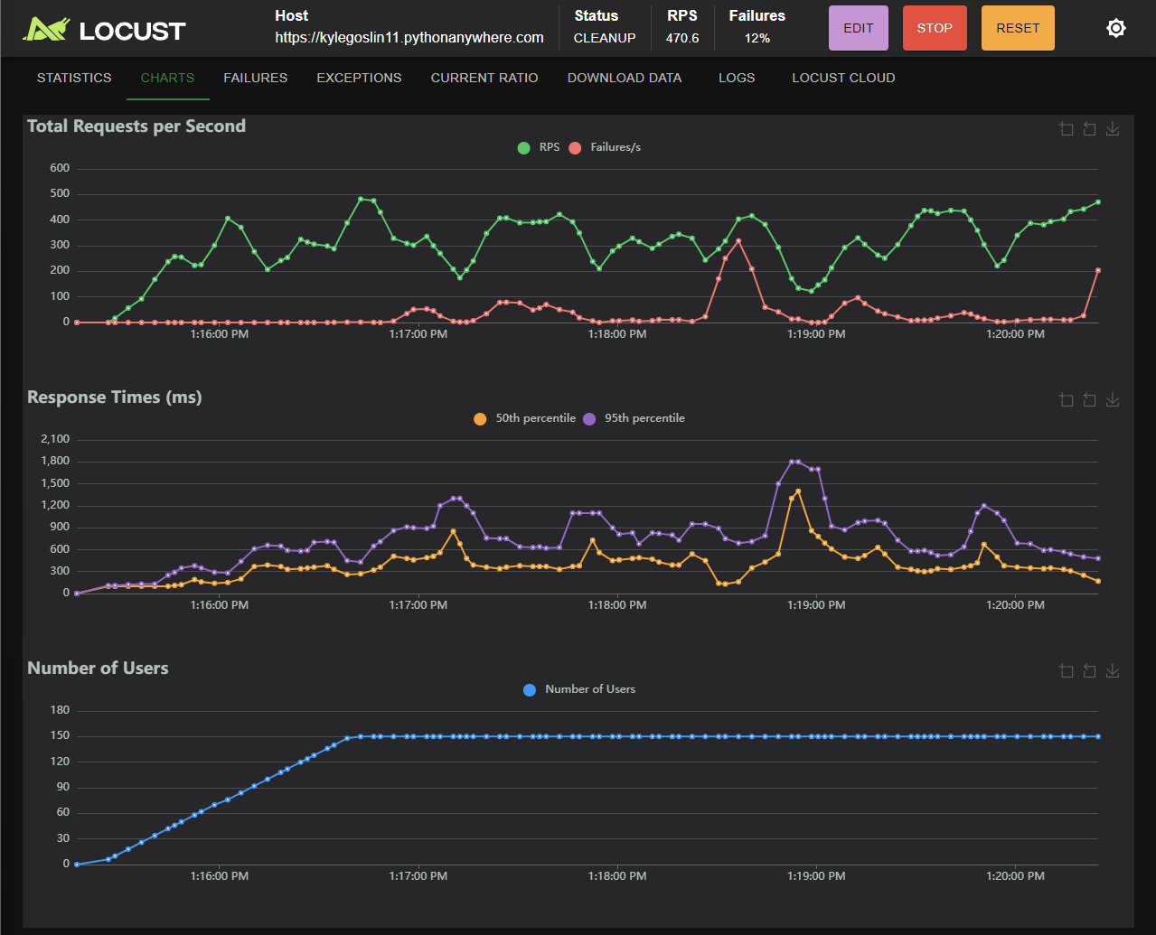

This number of users seems to be around the viable limit for this server and page, with failure rates around 12 percent overall, and at times almost all requests were returned as failures.

Requests per second rose and fell between 500 and 100 per second, averaging around 300 per second, still acceptable.

The most notable result of this test was its inconsistency. This number of users is definitely approaching the maximum viable number

Local machine CPU / RAM Load - What impact did this have on your machine?

CPU and RAM load stayed consistent throughout this test

What did the test results show you overall?

Overall, this test shows that this 150 users is likely the maximum number of users for this page on this server. It also showed that the performance of this server can be somewhat inconsistent over time, despite having the same load throughout the test

Could the server handle the traffic in your opinion? Why or why not? What evidence backs up your claim? What was the maximum amount of traffic the server could take?

The server could handle the traffic in this test, although it with at response time averaging 1 second and reaching 1.8 seconds, a 12 percent failure rate for requests overall, and somewhat inconsistent metrics throughout, 150 users is likely the maximum number of users this server can handle at one time.

If this number of users or more are expecting to be using the page at a time, a server with better performance may be needed

